Deanna Hogan
ODACA Artist since 2006

Contact me: deanna@blueherondolls.com

The Fundamentals
Tip #3: Sewing Stripes

I love using striped fabric for dolls’ legs. Achieving perfectly matched stripes is so satisfying.

It’s not that it’s difficult to match stripes. The problem is maintaining those perfectly aligned stripes while machine sewing. On standard sewing machines the feed dogs maintain close contact with the fabric on the bottom and may pull that layer of the fabric more than the top layer. Even if you use a gazillion pins, the fabric may still shift.

I want to share a trick I learned from my friend and fellow
doll artist Brenda Gehl. Use a glue stick. You don’t need to
use anything fancy or a fabric-specific glue, as you’ll be
washing/rinsing the glue out of fabric when you’re done
sewing. I have a few different glue brands on hand, so I’m
not advocating one brand over another.

If you’re unsure if this will work with your fabric, be sure
to test it on a swatch.

Here’s my process:
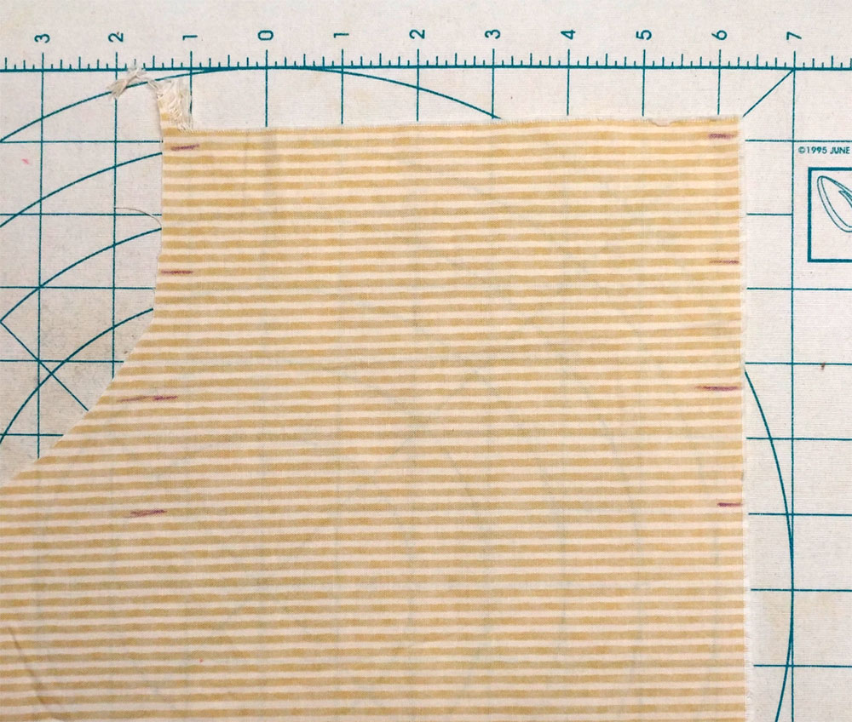 | For this doll I used a very narrow stripe, so I wanted to make sure I followed the stripes from one end to the other accurately.  I used an air/water soluble pen to mark the stripes at intervals.
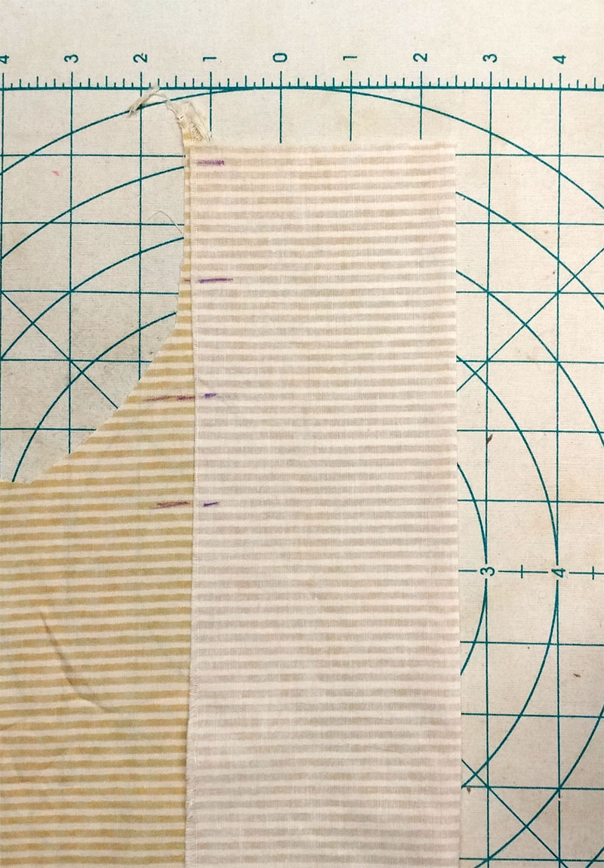 | Next, I carefully folded the fabric (right sides together), matching the stripes and my pen marks.  I pressed the fabric to create a neat crease and eliminate any wrinkles.
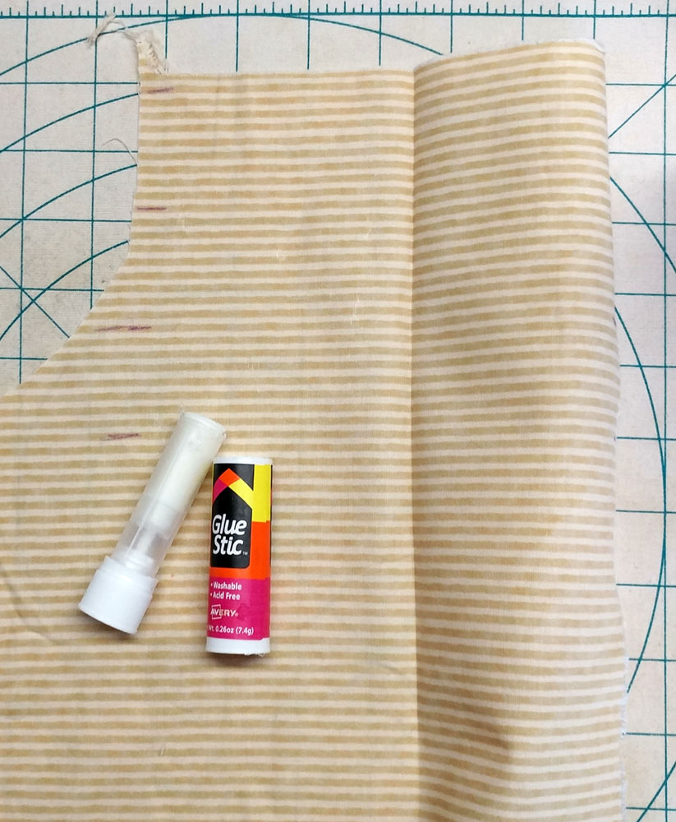 | Then I use my glue stick to apply enough glue to hold the fabric together and prevent any shifting – not over the entire surface, but just enough to hold the fabric together securely.
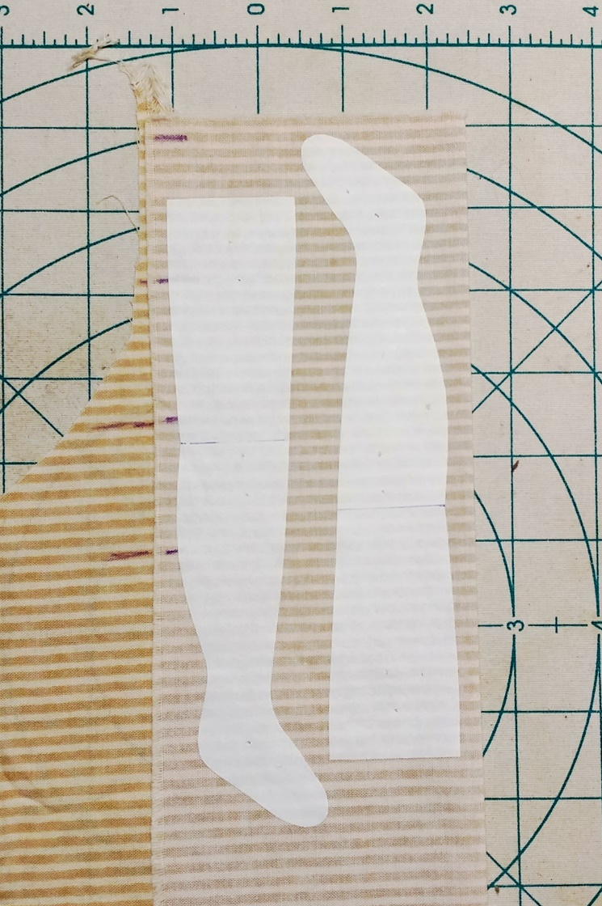 | I ironed the templates to doubled fabric.  I pay attention to the stripe at each leg opening so when the legs are sewn, stuffed, and attached to the doll, the stripes match from one leg to the other. In this case, the stripe along the edge of the opening was the tan one. This is more obvious when using wider striped fabric.
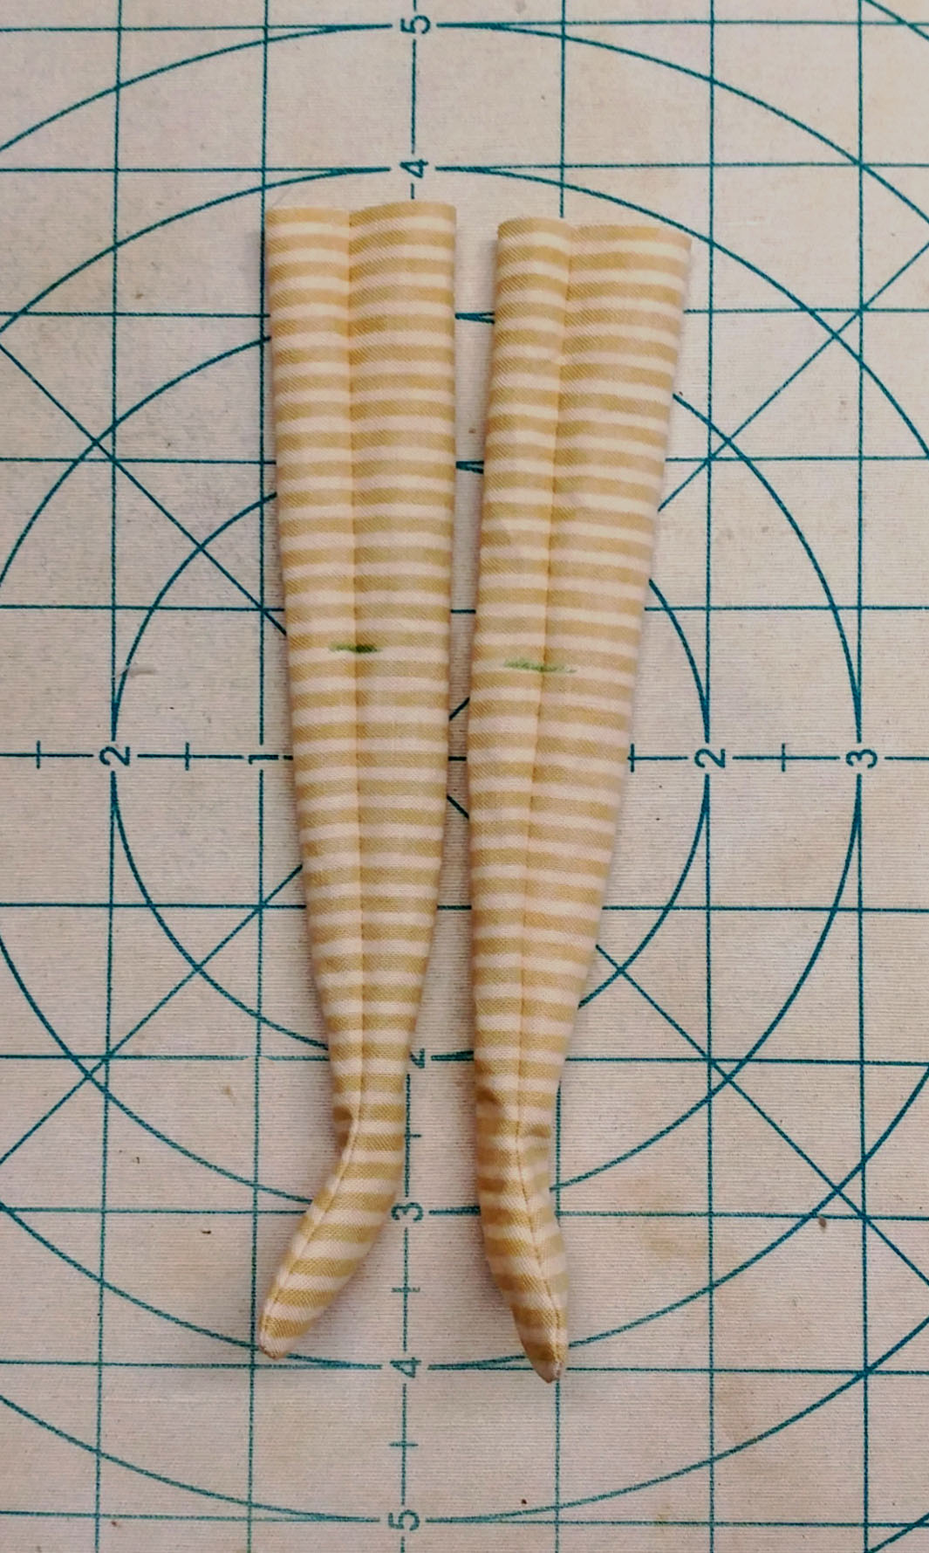 | The legs are turned right side out and are ready to hand wash to remove the glue and pen marks.  Look at those perfectly matched stripes!

