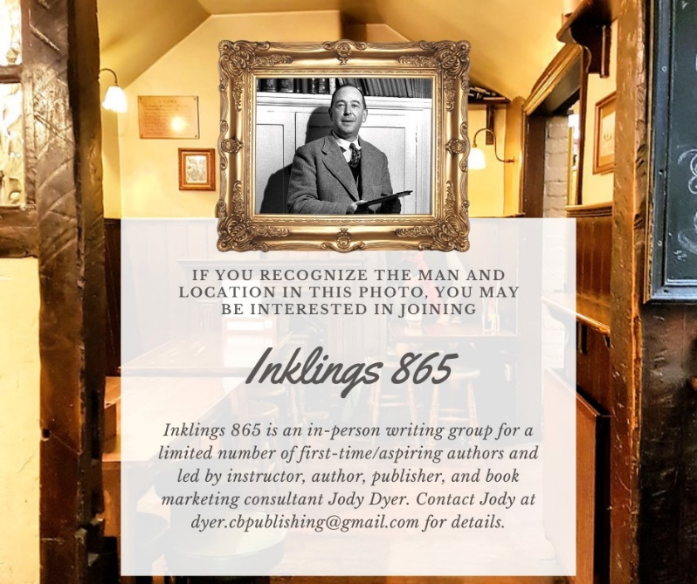

Hello there my fellow creative,
Thank you again for your interest in what could be a reward and productive writing experience.
Inklings 865 (an in-person, East Tennessee writing group) is in the works and will begin March 1, 2022.

I am capping the group at ten participants, so if you are interested, tell me as soon as possible.

My #1 goal is to help you start and, ideally, finish a first rough draft in six months. That’s a BIG goal, so we will work quickly. Your efforts outside the group are crucial to your success. That said, you can learn with the group and take your time. Books are art forms, and sometimes writers need extra time to think, brainstorm, outline, research, and, of course, write. Some projects are lengthier and more complex than others. Plus, this group is open to all genres, which I believe will enhance each person’s experience.

Requirements:
- You must be serious about writing a book.
- You must be willing to read aloud to the group.
- You must be willing to offer constructive feedback.
- You must encourage fellow authors.
- You must be open-minded, reasonable, and polite.
- We will NOT discuss politics, religion, marital issues, personal finances, or how much we love our pets. We just don’t have time.
- This group is about WRITING, so instruction and discussion will be about, well, writing. If you’d like to know about book editing, publishing, and marketing, you can schedule a separate one-on-one appointment with me. You’ll also get weekly emails from me that include tips (and often include freebie downloads) on those topics.

Inklings 865 membership includes:
- Monthly meetings for six months - I will facilitate two, two-hour group workshops per month. Some will be on Tuesdays, and some will be on Thursdays. We are all busy, so perfect attendance is suggested but not required. I'm mixing up the dates a little to accommodate as many members as possible (hopefully all members). Meetings will take place in evenings. We’ll meet at my home or the home of volunteer members. If you are allergic to cats, please tell me so I can arrange for meetings to take place elsewhere.
- Each meeting will include well-researched instruction and relevant supplemental materials (checklists, guides, cheat sheets, charts, and other support documents).
- The remainder of the meeting will be structured but allow for practice, discussion, and feedback.
- We will meet in person unless there’s a strange weather situation or I am contagious (not my personality---my biology). In those situations (unlikely), I invite a guest speaker or ask a group member to facilitate the meeting.
- You will have access to the Crippled Beagle Publishing Q and A Google Sheet (new and growing). The sheet includes questions about writing, editing, publishing, marketing, and more from all CBP clients.
- You will have access to my weekly office hours: Mondays from 12:00 PM to 2:00 PM EST. I will answer phone calls and emails. I will answer as many emails as possible during that two hours. My team and/or I will also add your questions and our answers to the CBP Q and A Google Sheet.
- You will be on my weekly email list, through which I share industry news, inspiration, tips, and much more about all phases of the writing and publishing process.
- Inklings 865 members enjoy 10% off any Crippled Beagle Publishing product for the life of the product. Don’t be shy about reminding me!

SCHEDULE:
Meetings will take place from 6:00 PM to 8:00 PM. We will begin work promptly at 6:00 PM.

DATES:
March 1 and 24
April 7 and 21
May 5 and 24
June 2 and 21
July 12 and 26
August 2 and 30

PAYMENT OPTIONS --- Full or first payment must be received by March 1:
- Pay in full up front $1350 (save 10%)
- Six-month payment plan (debit card/credit card required, processed automatically) $250/month

What you need to do now:
- If you want in, tell me ASAP. Call/text 865-414-4017 or email dyer.cbpublishing@gmail.com or jody@crippledbeaglepublishing.com.
- If you are committing now, tell me how you would like to pay, and I’ll share instructions.
- Send me any questions or ideas you have about Inklings 865. Email dyer.cbpublishing@gmail.com or jody@crippledbeaglepublishing.com.

Let’s write some books!
Jody

